System Architect Essentials

Best Practices and Guardrails

# Introduction to best practices and guardrails

In this lesson, you will learn best practices for designing and building applications.

Some best practices help you deliver business application development projects successfully.

Other best practices help you design business applications with fewer defects.

Following best practices increases your chances of overall project success.

## Objectives

At the end of this lesson, you should be able to:

* Explain the purpose and benefits of best practices.
* Identify Pega best practices.
* Identify the most important best practices when building a Pega application.
* Explain how Pega guardrails indicate flaws in an application design.
* Describe the information provided in guardrail warnings.
* Located guardrail warnings in Designer Studio.

# Purpose of best practices

A close up of a logo

Description generated with very high confidenceBest practices are well-defined methods or techniques that lead to desired results.

Every best practice has at least one goal.

A best practice is proven to make progress towards achieving its goals.

If an organization follows best practices, it can predict a desired result with minimal problems or complications.

Best practices are used in everyday life.

For example, when preparing a meal, a best practice is to always use a potholder when touching a hot pot.

The goal is to not burn yourself, and using a potholder is a proven way to prevent your from burning yourself.

As you design and build your application, establish and follow best practices to increase your chances of project success.

Look for existing best practices used by your organization and by Pega.

Select existing best practices or create new best practices to meet your goals.

Applying best practices increases the likelihood that your application is delivered on time and meets all its design requirements.

## Tips for establishing best practices

The standards for establishing best practices can vary, depending upon the needs of the organization and who is making the choices.

You can use several criteria to help choose best practices that will deliver measurable and predictable performance improvements for your application development projects.

### Is the best practice appropriate for your organization goals?

To be effective, best practices must address the specific goals of your organization.

For example, if an organizational goal is to ensure the protection of sensitive customer information, a best practice to outsource developers may not be appropriate.

The developers may also be working for the organization’s competitors.

### Does the best practice fit with the structure of your organization?

If a best practice places authority in a single person or part of the organization, it does not provide value if your project teams are supposed to be able to make their own decisions.

### Do you have the necessary resources to use the best practice?

Understanding what a particular, best practice requires in regard to resources – whether money, personnel, or skills – is essential.

Make sure that your organization can provide those resources before committing to a specific best practice.

### Is the best practice cost-effective?

If a best practice works wells for other organizations but requires an unacceptable amount of money or time to reproduce in your organization, it will be hard to justify the use of that best practice.

# Best practices for project success

With experiences from thousands of Pega project implementations, Pega has defined best practices that are key to delivering successful Pega projects.

Using some of the best practices identified below can help increase your chances of project success.

## Leverage DCO to improve product quality

Directly Capture Objectives (DCO) enables a project team to directly enter business requirements for an application into Pega.

Directly Capture Objectives (DCO) helps eliminate translation errors, saves the team time and effort, facilitates direct engagement of business and IT resources around visible working models, and enable project participants to optimally review work progress.

Pega recommends that all projects leverage DCO as a core part of the delivery process.

## Use standard Pega capabilities

Pega 7 has many features and capabilities built into the product.

Research the Pega Discovery Network or Pega Platform Help to find a Pega solution that already exists for your task.

Use Pega capabilities, which have been tested and proven reliable.

For example, assume you want a process to require increasing levels of management review based on the amount of the loan request.

Rather than building the process yourself, use an approval process that Pega has already built.

You can modify the process to support your requirements in a fraction of the time needed to build the process.

A screenshot of a cell phone

Description generated with very high confidence

## Iterate and test as you build

Use the most agile, iterative delivery model that your organization can adopt.

First, separate large applications into smaller, more manageable components.

For example, instead of building the complete application and then testing the completed application at once, build and test individual processes incrementally.

Then, demonstrate completed features to interested parties who can provide feedback.

A close up of a sign

Description generated with high confidence

Begin testing early in the project life cycle to drive higher levels of product quality.

Test each new feature or capability to make sure it works.

Then, test the system for processing issues that may affect performance.

Also, check to see if the new features work together without error.

Finally, have analysts test the application to make sure the application meets the requirements and business objectives.

## Ensure project team members are certified

Project success depends on a complete and capable team.

As a guideline, Pega recommends that all team members hold the appropriate certifications for their roles.

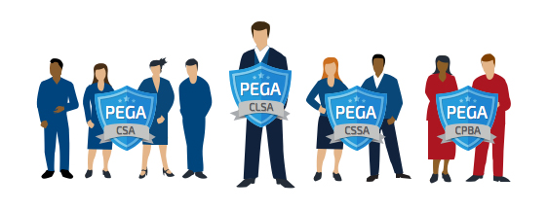

Pega recommends that business architect and project management resources pass the Certified Business Architect exam.

All developers should, at a minimum, pass the Certified System Architect exam.

## Follow Pega guardrails

Pega guardrails help ensure that you use best practices for configuring Pega applications.

Pega’s powerful capabilities offer many possible approaches to create a specific design requirement.

Not all of those approaches are the best solution.

Pega provides standard guardrail capabilities that enable development team members to track compliance with Pega best practices.

Compliance with the guardrails results in applications that are easier to maintain and upgrade, and have significantly fewer defects than non-compliant applications.

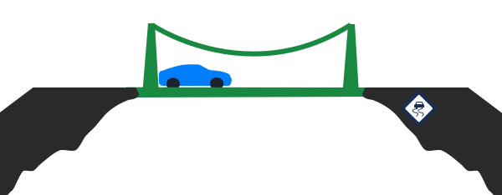

## Collaborate with everyone invested in the success of the project

Collaborate with individuals interested in making your project succeed.

Bring business users, business analysts, and system architects together so they can share their unique skills and viewpoints.

For example, business users and business analysts who have in-depth knowledge of the business process can help capture accurate requirements as well as design and optimize business processes.

System architects can help provide guidance on the best way to implement a business requirement.

### Knowledge Check

Q: What are the possible consequences of not following best practices and guardrails when designing and building an application on the Pega 7 platform.

A: When not following best practices, you may spend excessive time re-creating existing functionality, or debugging a component that is not well designed.

There is also the risk that you will implement a feature that does not work correctly.

# Guardrails for application design

Following the best practices when designing and building an application is important.

To help ensure your project’s success, Pega guardrails help you and your team track whether an application conforms to Pega’s best practices.

Following best practices can help you deliver applications that require less maintenance, have fewer defects and can easily be upgraded compared to applications that deviate from best practices.

Watch the following video to get a better idea about how guardrails can help you achieve project success, optimal performance, reuse, and maintainability for applications.

Video:

**Transcript for: Guardrails for application design**

*As you work with Pega 7 you will see messages.*

*These messages are important; they are known as guardrails.*

*Guardrails help to ensure that the application you create follows the known best practices for Pega 7 development.*

*When creating an application it is always a good idea to follow the best practices for whatever technology we are working with. What happens if we don’t follow known best practices?*

*By not following best practices we add increased risk that our application development effort could go off course and not. The application does not work as well as it could or should. It can also make the application difficult to maintain and update.*

*It is also possible that our application can get out of control and crash the project entirely.*

*Guardrails are best practices and guidance about situations that contain risky conditions or that might result in an undesirable outcome.*

*Guardrails ensure you and your team use Pega 7 the right way and help you avoid troublesome situations.*

# QUIZ

This quiz has been developed to test your understanding of the training content and to help you identify areas in which you might need to further review.

You may take the quiz multiple times.

**Question 1 –** An organization wants to automate its existing expense reporting process.

Which 2 actions should the organization take in order to follow Pega’s best practices for application design?

**Answers:**

1. Use DCO to enter business requirements for the application to facilitate direct engagement of IT and business resources.
   1. Note: Pega recommends that all projects leverage DCO as a core part of the delivery process.
2. Build and test the application before rolling it out for review by interested parties to ensure the application is ready for release.
   1. The organization should build the application iteratively and plan for regular reviews in iterative development cycles.

**Question 2 –** Select 2 benefits of following Pega’s guardrails.

**Answers:**

1. Guardrails help developers follow Pega’s guardrails, they are more likely to choose the best approaches, which lead to maintainable, reliable applications.
   1. When developers follow Pega’s guardrails, they are more likely to choose the best approaches, which lead to maintainable, reliable applications.
2. Guardrails help developers to track compliance with Pega’s best practices.
   1. Pega’s guardrails help developers choose the best approach to meet specific design requirements.